BlackLight

Daniel Rogers and Shobhan Roy

// Overview

Blacklight is a 3-D First Person Shooter, soaked in a futuristic, steam-punk inspired background, where it entwines a spectrum of different gameplay styles in an expansive, deep and sinister storyline with high-detailed, state-of-the-art environments, all driven with Havok™ physics.
Blacklight manages to bring a very dynamic and different world to what the average player is used to interacting with.

// Backstory

The year 2127 underlined the day to end all days. A meteor, 8 miles in diameter, was predicted to collide into Earth on March 7th, the warning being issued just under one month before the date. A lottery decided who would survive the end of days. The best of our species’ minds, engineers, technicians, scientists and doctors were slowly transported off the planet to space stations, mostly owned by mega-corporations back on Earth. On March 7th of that year, just over 200 million people watched as 16 billion souls disappeared in a shockwave of flames that engulfed the entire planet.

As time went on, it didn’t take long for the mega-corporations to take control as both the law and the government. A new race for survival to own key resource locations across the solar system came into play, but soon an alliance was formed between the mega-corps and stable trade routes established. But in the end greed once again took over and the more the mega-corps pushed for their own power, the harder the people pushed back against them. Several small colonies attempted to escape and form their own lives away from the mega-corps, but those that did were banished from the space, forced to become rogue traders.

2170 led to the sudden birth of a complex virus, which evolved spontaneously and fast against normal vaccines. In over the space of three years, it had infected almost every living person under alliance control, killing almost two-hundred thousand people. It wasn’t until a small research and tech corporation, GenoCell™, managed to create an engineered nano-vaccine to fight the virus. The problem was, because of the virus’ extremely fast evolution into new strains, the vaccine required “updating”. Every day, people would begin their day by injecting themselves with the latest “patch” for the vaccine. People were happy that GenoCell™ was taking care of them and soon the corporation became the largest and most profitable organisation in the system. Other people on the other hand, just saw it as the ultimate control.

With a new world once again ruled by greed and profit, people attempted to make a living in space as whatever they could be. The mega-corporations constantly striving for control demanded more enforced laws and security, to the point where there was a thin line between having an opinion and having a death wish. People were threatened through their families and friends to the point where no one would dare rise against the government that now surrounded them and lived for their own personal gain. GenoCell™ soon became the largest entity of control within the alliance, enforcing their laws with GenoVac™, the self-proclaimed name of their nano-vaccine, as well as their own police force… which was led by corp agents.

Corp agents were the backbone when it came to enforcement to GenoCell™, dark figures, filled with neuroaugmentations and physical bio-mechanical enhancements, ocular implants making them known widely for being able to see in the dark. Most agents believed in the law that they were born into, believed in keeping the peace and leading mankind out of darkness. They became known as Blacklight.

// Core Mechanics and Gameplay

This expansive background allows for a unique storyline, a mission-objective based gameplay mechanic and a very fluid character interaction system, which all work together to allow the player themselves to alter the progression of the storyline.

The plot itself is actually a complex tree of mission-objectives, that branch off into different sub-plots and secondary objectives, all of which collaborate to form a final outcome. The order and method in which these objectives are completed are what ultimately affect the final ‘ending’ for the player. This means that the player can make his way through the game several times, each time being able to complete the game in a slightly different way if he or she so chooses to, allowing the ability to access new gameplay assets and not dropping the CD after 10 hours game time.

Blacklight itself however, is still a first person shooter and holds all the same attributes that makes a good FPS. Based in the Source engine, the spawning ground for the hugely popular Half Life 2, this offers very easy control over the main character in a very detailed environment. The player begins as the main character, Chino, a Blacklight agent for GenoCell. At the character screen, you are able to control Chino’s basic in game “attributes”, such as his speed, strength, ability as using certain weapons, hacking computers etc. You have a certain number of ‘skill points’, which can be distributed to these attributes in order of the player’s game style. This brings a much more personified feel to the game, but not only that, as you complete mission objectives, you are rewarded with cash and skill points, which you can use to “upgrade” your Chino, therefore making him ‘stronger’ as he gains more experience throughout the game and therefore capable of taking on the harder NPC.

The way that mission objectives are also completed will affect Chino and the storyline. If he needs to acquire an item for example, he could either waltz in gun-blazing, or do more research and take it a little more covertly without being noticed. Since there are several other corporations (some who already hate GenoCell), you will be able to ‘missions’ for them also, increasing your standing to that corporation. Missions can and will involve doing things which will be directly against another corporations interests however and it will be up to the player to which route they want to take and what friends they want. A covert mission of infiltration may benefit over a gun-wielding hail of gunfire, since the corporation in question may never find out it was Chino and therefore you wont lose standing against them (have them shoot you if they see you). On the other hand, going in with your guns may attract attention from other corporations and get you more interesting jobs later on…

Valve’s Source™ engine, means Blacklight can become as expansive as it wants to be, it’s steam-punk essence of post-apocalyptical nature being illustrated in Source allows for very large environments, all with state-of-the-art graphics such as HDR. It also means that Blacklight can take advantage of Source’s dynamic and realistic Havok physics engine and use it to its advantage to make mission objectives more complex and interesting.

The game itself will feel generally dark and sinister, meant for the more adult gamer. The atmosphere itself is both futuristic, yet still has a very robust outlook. Bladerunner would be a good example of what kind of look we expect the game to have in terms of city environments. The implants act as the background for the main characters HUD, which includes information to weapons, missions, health, armour (which regenerates due to nanomachine repairs) and current implants which are in the player, enhancing certain attributes.

// Character Concepts

Chino (Agent 4802)

Chino (4802) was born into a city run by GenoCell; he excelled in combat and volunteered to become an agent to help keep the peace for the world he loved.

This is the main character, which is controlled by the player throughout the game. How Chino looks can be determined at the start of the game in an avatar-selection screen, where pretty much anything can be altered to desire, from his eye colour and clothes, to what kind of physical nano-augmentations protrude from his body.

Paul ‘G3neral’ Taylor

Where would any game be without the superhero’s best friend, who advises and helps him through the missions. Paul Taylor, commonly referred to in game as the ‘General’ is Chino’s contact from inside GenoCell. He is the one who uploads mission objectives to Chino’s ‘memory bank’ wireless implants, which can appear on the HUD at any required time, along with his advice on the subject. He would be Alex Jacobson from Deus Ex to JC (Chino).

Agent Mihoshi

A female assassin and deadly sniper. She aids Chino on certain missions, having greater skill than Chino at the beginning. Allowing her to die means you won’t be able to ‘use’ her for other missions if required, so keeping her alive would be in your best interest.

Blake Carson

This would be your typical bad guy in a black suit. He’s a senior director of GenoCell (the bad guys) and therefore cross fades from Chino’s commander to his arch nemesis. Missions from GenoCell will be issued from him to begin with, but as the storyline progresses, you will see less and less of him except via comms when he wants to tell Chino what a mistake he’s making for working against GenoCell.

// Media Asset List

Blacklight will be created in Source™, meaning a lot of the work for the game has already been done for us. However, this is still a very large complete Half-Life 2 conversion and therefore still has a lot of work to be done for it.

- A new HUD has to be created, which will be able to reflect the more futuristic, steam-punk drive. This will have to feel and look realistic to what Chino would see through his eyes, under augmentation. There will be a weapons load-out on screen, but it will not show how much ammunition is currently left, simply the number of magazines. Certain weapons may come with an ammo display, but only if it is more ‘energy’ based. Otherwise the player will have to take more initiative into reading the ammo display on the weapon model itself (if there is one).

- Character concept art and model bases need to be created as well as an avatar editor, which will allow the player to ‘morph’ and create the Chino to his own desire. Animation for these characters will also be required. New models will also include very futuristic looking robots and even vehicles, which will all require modelling, scripting and animating.

- Concept art for the environments will need to be produced and then mimicked using Hammer for the Source engine, creating maps for all the environments, all with full support for latest graphical enhancements in mind, such as taking the effects of HDR into account for certain maps to make it more interesting for the player instead of just another graphical gimmick.

- A specialist ambience music composer will be required for the music composition. Work by Jon Hallur would be the inspiration, which will reflect the focused, relaxing ambience in the environments as they are in all perspective of time and place.

// Project Plan

Aims and Goals:

Our general timeframe to produce this title is about 12 months. This includes everything from additional scripting and modeling to animating, mapping and music. Our aim will be to release a refreshing updated conversion of the Source engine to really expand on its full capabilities, to allow this dark, complex and sinister FPS to bring back storylines and huge sub-plot micromanagement back to the genre.

- Additional scripting for the title to include more complex NPC interaction in terms of being able to talk to them the way you want (being able to choose from a list of sentences, re: Deus Ex). The new HUD, implant and augmentation implementation and attributes to change character enhancements. Development for the avatar-creation screen will also need a fair amount of coding.

- The background and screenplay for the entire game will have to be written up to dictate characters and maps for mission-objectives.

- Character modeling and animation for all the characters within the game, including specifics in-game characters along with ‘grunts’. New models for the new vehicles and robots will also have to be made, with appropriate design, textures, animation and scripting. The player will have the ability to drive some of these vehicles.

- Maps for all the environments will need both a 2D design and 3D mapping in Hammer with the new terrain textures and design.

- A thick ambience must be created to fulfill its role to keep the player on edge or relaxed dependant on the environment, the music reflecting its atmosphere as well.

Schedule and Deliverables:

We’re looking at approximately 12 months of work, with a team of 14 working on Blacklight.

Month 0-1:

- Complete document of main storyline, with included sub-plot branches.
- Character, Model and Environment concept work begins.
- Source code breakdown and scripting begins to implement new game tech.
Deliverables: Document of Blacklight outline to dictate concept art.

Month 1-3:

- Character, Model and Environment concept work completes with models and mapping getting underway by the start of the 3rd month.
- HUD development begins in collaboration with scripting work
- Music composition with storyline and concept art as a base begins.
Deliverables: All concept art by the end of the 3rd month.

Month 4-6:

- Textures for models and environment design begin.
- Animation begins for what models have been created.
Deliverables: Complete HUD, ready to implement models with NPC interaction script ready to test. Some character models and maps, with beta demo.

Month 7-9:

- Character model completion, Model completion with animations
- Implementing character models and vehicles to see them work under the new script alongside the new maps.
- Testing begins with implementation.
Deliverables: Completed Character and vehicle models with animation. First demo test with a generally polished map, including textures, sound and interaction to be delivered by the end of the 9th month.

Month 10-11:

- Mapping completes alongside Texture designs, leading to the full game’s maps being finished and polished by the end of the 11th month.
- Music is finalized and evaluated, before being implemented into the game play.
Deliverables: Beta version of finished title should be ready by the end of the 11th month, with excessive testing underway.

Month 11-12:

- Bug testing to bring the final gold version out for release on Steam.
- Last minute alterations to game mechanic if required
Deliverables: Blacklight.

// Budget

As the game is a total conversion for the Source™ engine, we are able to work with a smaller team. However, with our publishers and distributors being one and the same company, we expect a bigger return.

Budget:

Salaries: £260,000
Workplace Rent: £50,000
Equipment: £16,000
Licensing: £20,000
Marketing: £10,000
Buffer: 15%

Total Budget: £409,400

As you can see, most of our budget is used paying for out hard working team with a strict deadline of 12 months in which to get the game ready for release, they could be hard-pushed. We also require fewer computers, but these do have to be top of the line machines, and at £2,000 each, this increases the cost. Licensing and Marketing will go to Valve for the use of the Steam™ distribution software and Source™ engine. I have also included a 15% cash buffer for unforeseen events. This might be a bit conservative, but with a small, but disciplined development team, we should hit budget.

// Technical Specifications

For this game, we want as many people to be able to play it with acceptable performance as possible. This is why we have chosen to use the Source engine; it is incredibly scaleable. Compatible all the way back to DX7 cards, but can also push new cards to their limits with HDR lighting. As such, we are aiming to have the same minimum specifications for Blacklight as Half Life 2:

Min:
• 1.2 GHz Processor
• 256MB RAM
• DirectX 7 graphics card
• Windows 2000/XP/ME/98
• Mouse
• Keyboard
• Internet Connection

The minimum specifications would run the game without all the shaders, water effects, particles and HDR.
Preferred:
• 2.4 GHz Processor
• 1GB RAM
• DirectX 9 graphics card (GF 7 series/ATI X1900 recommended, SLI/Crossfire)
• Windows 2000/XP
• Mouse
• Keyboard
• Internet Connection

This setup will allow the game to run at higher resolutions, with Anti-aliasing and/or HDR effects activated, making the game appear at its full potential.

As we are planning to distribute the software via Valve’s Steam electronic distribution program, an Internet connection is required to install the software.

// Marketing

Due to the content of the game, the game would have a high age rating, 15+ or even 18+. This means we would have to be very careful about what footage we used in advertisements. The game would be pitched towards the older teenagers and above.

We will organise adverts in PC magazines and online websites. We could also supply a demo for PC magazines’ cover disks, or a downloadable demo from either file planet or though Steam itself.

We could also work out a sponsorship deal with a TV series, similar to what THQ did with Destroy All Humans and Full Spectrum Warrior. On digital TV, Adverts for the games ran before and after Star Trek episodes.

// Competitor Analysis

Hitman: Blood Money

FEATURES

Earn payment for the successful assassination of targets, the more professional your approach, the higher the reward.

Play stealthily like a professional assassin or take out everyone in your path, but don't expect to escape the consequences if you leave a trail of evidence behind you. Your notoriety will affect your passage through the game.
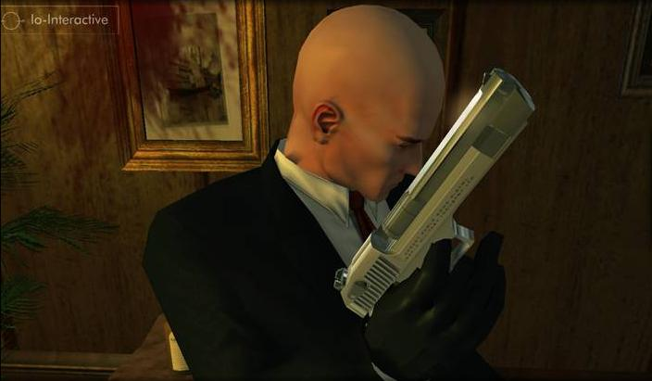

Use the funds you accumulate to purchase custom built weapon parts, to increase precision and effectiveness and reflect your preferred playing style.

The world of the assassin has never been so interactive or looked so good. Living, breathing locations based upon real word environments and scenarios create a multitude of assassination possibilities, potential challenges and re-playable scenarios. Whilst never before seen levels of detail; including next-generation technical effects add even more realism to the game.


Use the environment to your advantage, climb, scale and vault through your surroundings, to hunt down and eliminate your targets.

New reactionary moves allow you to respond to the situations at hand - use hand to hand combat, distraction, hostages and many new assassination techniques to reach and take down your targets

Realistic world simulation, with intelligent civilians and hostiles, observe and react to your behaviour and respond to your notoriety.

Fully dynamic camera, featuring 1st and 3rd person modes.

Half Life 2: Episode 1
Half-Life 2: Episode One is the first in a series of new adventures created by Valve that extend the Half-Life 2 single player experience. It details the aftermath of Half Life 2 and launches a journey beyond City 17.
Stepping into the hazard suit of Dr. Gordon Freeman, you face the immediate repercussions of your actions in City 17 and the Citadel. Rejoin Alyx Vance and her robot, Dog, to once again aid the human resistance in their desperate battle against the totalitarian alien menace of the Combine.
Episode One exposes Alyx's combat skills and knowledge of City 17. Battle side-by-side with her through Valve's first episodic game, a four-to-six hour adventure of greater density and detail than non-episodic releases.
In addition to the new single player campaign, Half-Life 2: Episode One also includes two multiplayer games. And everything you need to play is included in the box – Half-Life 2 is not required to play.
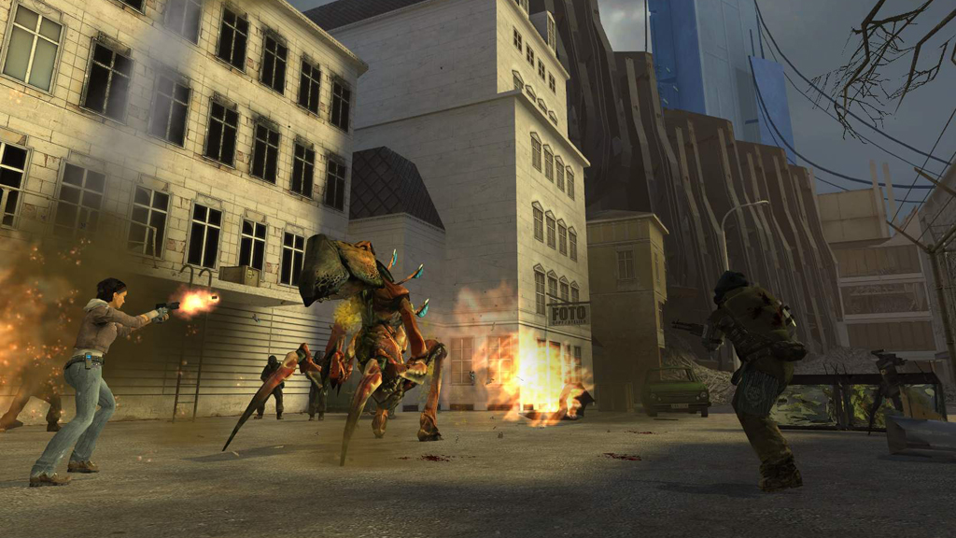
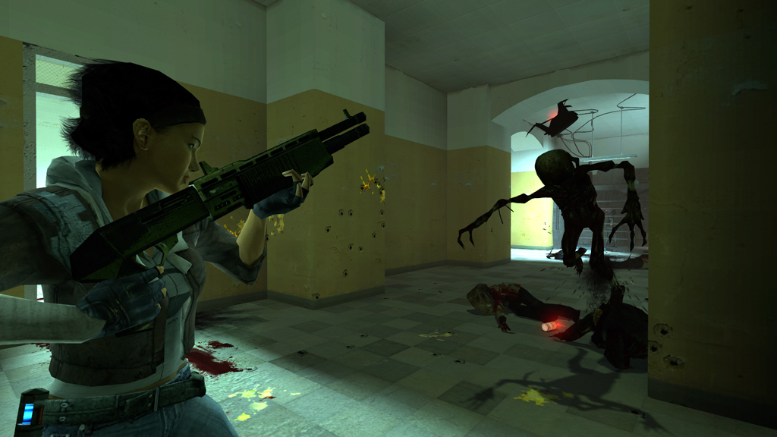

Features
- An all-new episode for one of the best-selling action games of all time.
- Discover what’s become of City 17, Dr. Breen, and the G-Man.
- Incredibly advanced Artificial Intelligence (AI).
- Highly detailed environments, featuring High Dynamic Range lighting, provide amazing gameplay settings.
- Digital Actors: The most sophisticated in-game characters ever witnessed.
- Physical Gameplay: Objects obey the laws of gravity, friction, and buoyancy.
- Design Team Commentary Mode.
- Also includes two multiplayer games: Half-Life 2 Deathmatch and Half-Life Deathmatch: Source™.
- Half-Life 2 not required to play.
As we can see, these are the top-of-the-line games, Hitman being the latest assassin, gritty game and HL2: Episode 1 being the latest the Value team has to offer. Other games that might come into direct competition to Blacklight include FEAR, developed by Monolith Studio’s and up-and-coming MMO Twilight War.

// Team Structure
As we are licensing the Source engine, we will not need to build an engine from scratch. Therefore, we can save money by not having as many programmers.
A production team could be made up of:
- 2 Programmers (1 Lead, 1 normal)
- 2 Designers (1 Lead, 1 assistant)
- 2 2D Artists (1 lead, 2 environment, 2 character, 2 items)
- 3 3D Artists (1 lead, 2 environment, 2 character, 2 items)
- 1 Project Manager
- 2 Sound Engineers (1 music composer, 1 assistant)
- 2 QA (1 Lead, 1 normal)
If we find that this is not enough people to cover all the tasks, we might need to bring in so freelance workers to bridge any gaps.
Project Manager

Lead Designer
Lead 2D Artist
Lead 3D Artist
Lead Sound
Designers
2D Artists
3D Artists
Sound

QA Team

Here is how I imagine our communication infrastructure will be set up.

// Game Flowchart

Here we see how the player will progress though the game:
Player Receives Mission
Player proceeds to mission objective
Player chooses how to complete mission
Fail Mission
Reload or restart
More/better rewards
All Objectives
Normal Rewards
Primary Objectives Only
Progress of Storyline
Alternate progression of Storyline
Find new mission NPC
Player Actions

// Project Diary

15th May 2006

After a meeting about the project, we split up the tasks for the assignment equally:

Shobhan Roy
- Overview & Mission Statement
- Gameplay
- Background Synopsis
- Characters
- High level Media/Asset List
- Project Plan: Aim/Goals/Deliverables/Schedule/Milestones

Daniel Rogers
- Marketing Info
- Budget
- Competitor Analysis
- Technical Specification
- High level Game Flowchart
- Team Structure

17th May 2006

Shobhan brought together the general background and concept for the game, which was then evaluated between both Dan and himself. After a conclusion was drawn on the decision, this made it easier to see what kind of title we were making and what was the best way to go around planning its development. Deciding on the Source Engine managed to make things a lot easier, in terms of gathering information on current projects. Work then continued.

22nd May 2006

A meeting was held over MSN to see how the work was coming along so far. Shobhan had completed both the Overview and Gameplay for how the game would work. Dan had a finished marketing base and had researched the current competitors for our title in the same market. Technical specifications for the game were decided upon and work continued. The vision document with research from inspirational games of the title as well as background comparison was also completed.

24th May 2006

Approaching the near end of the project deadline, another meeting was held at “The Old Pint Pot”. Here we managed to settle on a team size, which allowed Dan to finish the last sections of Team Structure and also produce a very suitable Game Flowchart to mission based objectives.

25th May 2006

Last MSN meeting before deadline to evaluate the finished project, editing details as necessary and making sure the information gathered was intelligent and collaborated with the overall project nicely. Shobhan completed his sections by finalising a list of the aims, goals and deliverables for the timeline given for the title. All work was sent to Shobhan in order for submission on Friday.

