

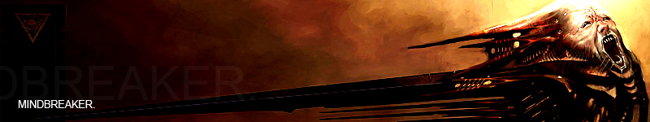

Table of Contents:

// Introduction -- 1.00 [Page 3]
- Title – 1.10
- The Mindbreaker Concept – 1.20

// Special Features and Unique Selling Points –- 2.00 [Page 4]
- Features of Mindbreaker – 2.10
- Next Generation Love – 2.20

// Game Modes –- 3.00 [Page 5]
- Story Mode – 3.10
- Tutorial Mode – 3.20
- Survival Mode – 3.30
- Time Attack Mode – 3.40
- Playground Mode – 3.50

// Gameplay Mechanics –- 4.00 [Page 6-8]
- Attribute Bars + Level Features – 4.10 [p6]
- Player Abilities – 4.20 [p6-7]
- Game Controls – 4.30 [p7]
- Monsters and AI systems – 4.40 [p7-8]
- Potential Weapons and Damage System – 4.50 [p8]
- Camera Angles – 4.60 [p8]

// Story Overview –- 5.00 [Page 9-10]
- Waking Up – 5.10 [p9]
- Nightmares of Reality – 5.20 [p10]

// Game Progression / Level Walkthrough –- 6.00 [Page 11-13]
- Levels – 6.10 [p11]
  - Early Complex – 6.11 [p11]
  - Omerta Black – 6.12 [p11]
  - Clone Bay – 6.13 [p11-12]
- Simple Room Concept – 6.20 [p12]
  - Map Concept – 6.21 [p12]
  - Map Key – 6.22 [p12]
  - Level Walkthrough – 6.23 [p13]
  - 60 Second Level Gameplay – 6.24 [p14-15]

// Competitive Analysis – 7.00 [Page 16]
- Alice – 7.10

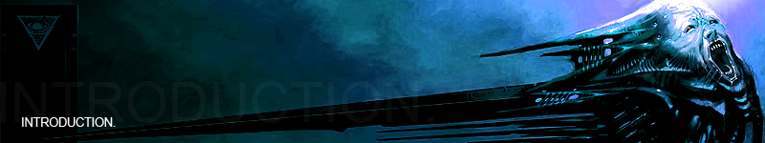

[// 1.00]

1.10
Title: Mindbreaker
Genre: 1st/3rd person, 3D Action Platform
Number of Players: 1
Target Area: Teen+
Violence Level: Med/High
Number of Environments: Constantly evolving environment/levels

1.20
Mindbreaker is a 3D puzzle-driven, action platform game for the Nintendo Wii exclusively. By forcing the player to both tactically and strategically comprehend and manipulate some extremely, constantly evolving, twisted environments using Havok™ physics, in a make-believe, drug-manifested world of monsters, floating objects and sadistic doctors, Mindbreaker plans on creating a good reason to not play Mario on lysergic diethylamide.



[// 2.00]

2.10
Features Of Mindbreaker

- Taking complete advantage of the unique gameplay controls that the Nintendo Wii has to offer, the player can use the nunchuks to “grab”, “move” and “throw” different sized objects in the ever evolving world, in order for him/her to navigate their way through the level.

- By collecting antidotes or in reverse, being infected by a doctor, will have varying effects on the level itself, from changing the shape of the environment (i.e., changing concrete to lava) to adjusting the physics of the level, such as removing gravity on certain objects – making the level harder, easier or impossible to complete.

- Limited weapons, of which all are close range, forces the player to use the “created” world to their advantage, in order to dispose of their enemies - instead of relying on ammunition, weapon drops and reloads to determine their success.

- Being able to change from 1st to 3rd person view at any time, to better visualise the landscape for plans

- Real-time HDR lighting for truly ultra-realistic graphics in an unrealistic environment

- Havok™ physics for realistic manipulation and control of in-game assets, with fluid rag-doll animation.

2.20
These special features are the primary reasons to why Mindbreaker is going to stand out from the rest of the 3D action platformers. By bringing a first-person feel to the Nintendo Wii’s next generation interaction capabilities, the possibilities are endless.

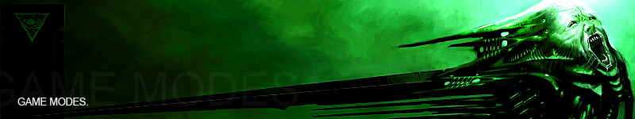

[// 3.00]

There will be 5 separate game modes, consisting of:

- Story
- Tutorial
- Survival
- Time Attack
- Playground

3.10
- Story Mode is the story based, highly-scripted version of the game, which throws the player into the deep, twisted world of Mindbreaker, giving a reason for them to try to escape the hellish nightmare that is their current reality. The simple aims being to find the “Exit” doors, by solving each room via antidotes and manipulating the environment. Consisting of detailed, scripted levels all in a specific order to the story itself, drive this mode as the real game.
3.20
- The Tutorial Mode is a simple learning mode, which teaches the player how to play Mindbreaker. Using the nunchuks to move parts of the environment to kill monsters, navigating the world itself and also the effects of antidotes/infections in Mindbreaker are all released here.
3.30
- Survival Mode is all in the name, based purely on survival, levels are infested with monsters; however the willpower bar will recharge much faster than normal. The player has no weapons other than her mind, which she must use to kill as many monsters as possible, using boxes, barrels, small cars – etc. The more enemies she kills, the more that respawn to take their place. Survival mode is all about seeing how long you can survive against massive torrents of monsters, in this twisted world. This is also a good mode to train against quick response times for other modes.
3.40
- Time Attack mode is almost the complete opposite of survival mode, except for the fact that it is practically Story Mode, with a time limit. The player has a limited amount of time to complete a typical level from Story Mode. If the level is completed under the required limit, then they may pass to the next. Completing the level before the time-limit runs out, allows the player to be rewarded with “willpower boosts”.
3.50
- Playground is and probably could be the most entertaining aspect to this game, when not playing Story Mode. It is basically the equivalent to playing in a physics tech-demo, with the Nintendo’s nunchuks. Several items, objects and monsters are all spawn-able on demand, to then do whatever the player wants to. Creating large towers of barrels, before throwing a monster into them, all with the flick of your wrist has proved quite entertaining already.

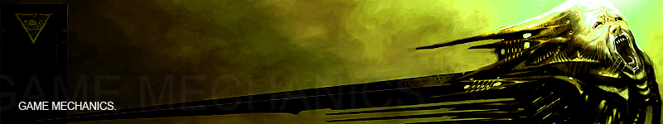

[// 4.00]

4.10
Attribute Bars and Level Feature Examples:

The player starts with the general knowledge that they’ve been drugged, noticing a health bar and a willpower bar immediately showing up in the bottom left hand corner of the screen. Monsters and hazards in a level can decrease this health bar. This health bar never regenerates, once a hit is taken, you will stay there – until the next level. Another “bar” takes up the top right-hand corner of the screen, in the shape of a cardiac monitor.

Naturally, if this health bar decreases the zero, the player dies. The willpower bar and the cardiac monitor are both indications for two other effects on the player and their surroundings respectively. Monsters may be able to affect the player’s health; however, Evil Doctors have effects on their sanity. The player’s sanity, dependant on how insane/sane they are, changes the cardiac monitor – beating faster when they’re starting to lose their sanity. As their sanity decreases, the level will change, to become much harder to complete – if not impossible, with the only chance of survival bestowed upon the glowing green antidotes, scattered around the level.

A player may start a level in a room, filled with lava, and floating cars – probably a car-park in the real world. However, because their mind thinks it’s real, it is real – just like the Matrix. Picking up an antidote may stop the cars from floating, allowing the player to use them as skipping stones over the lava. While on the other hand, getting infected by another doctor may cause it to start raining meteorites.

The willpower bar is essentially the players “strength” in the game. It regenerates very slowly when the player is insane and faster when the player has a little more grasp on their surroundings. Willpower gives the ability to pick up and move objects, to either place somewhere (i.e. moving a box underneath a platform in order to reach it) or using it as a projectile against their enemies. Each time an object is manipulated, dependant on the size, a fraction of willpower is used up. Willpower must therefore be used intelligently, as random use of it may end up killing you in the long game. However, killing enemies will give you a “willpower boost”, filling up a certain amount of the bar, dependant on the game difficulty.

4.20
Player Abilities:

Players has the ability to move forward, back, strafe either left or right and also turn left or right, using the nunchuks controllers. They are also able to duck and jump on demand. Tapping either the left or right strafe buttons twice will also cause the player to “dodge” in that direction, from incoming attacks.

The movement controls are fairly generic as far as normal first-person shooter games function, however, the ability to aim is integrated with the motion nunchuks. Wherever you aim the controller at the screen, is where the player will “lock on” to. Aiming at objects brings about the ability to “wield”, “pull” and “drop”. Using a mixture of the three abilities on objects, along with improvised inertia (by moving the nunchuks) will allow the player to throw objects into monsters or into other objects – or creating makeshift bridges to walk across.

It will be these functions that define the game as it stands apart from other platform games. The plan is to make the controls feel as fluid as possible, to the point where the player believes he can manipulate any part of the environment at his own discretion (or not so discreetly), with very fast, simple movements.

4.30
Game Controls:
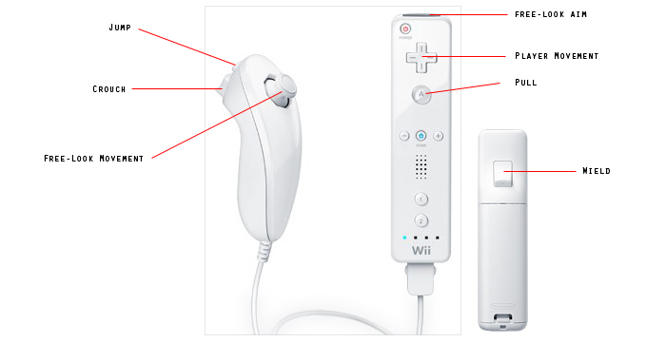

4.40
Monsters and AI systems:

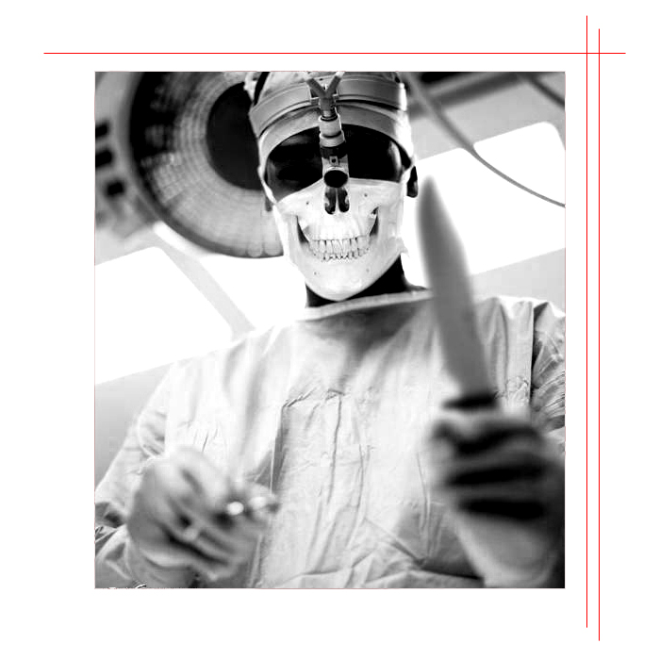
There will be several types of Monsters in this game, but they’ll be mainly split between either being Monsters or Doctors. All monsters will have the ability to inflict varying amounts and types of damage on the player, along with acting differently in order to do so. Some for example will attempt to make it harder for you to get across the level, by breaking bridges and disposing of possible weapons that you could use against them. Others may want to fight up-close, with no care for them or other monsters – nothing but a pure intent of killing the player. Thankfully, you can use objects in the world as shields to protect yourself from whatever imaginative fireballs, lightning bolts, or projectile weaponry the monsters decide to dish out at you (and if desired, throwing said shield in their face after you’re done).

As already mentioned, the second type of “monster” in the game will be doctors. Doctors, unlike monsters, cannot affect the player’s health bar. However, they can increase the concentration of drug dose in your system, causing your cardiac monitor to increase and darken in colour – but more importantly, changing your environment to that of a much more twisted one.

Doctors are very easy to kill, but are stupidly difficult to catch, since they appear at random moments, almost out of thin air.

They can travel over any terrain, no matter what mind-state the player is currently in, until they reach the player to infect them. They are still prone however to projectile objects. If a doctor gets too close, they will be able to infect the player – before disappearing in a fit of sinister cackles.

4.50
Potential Weapons and Damage System:

Bone Saw
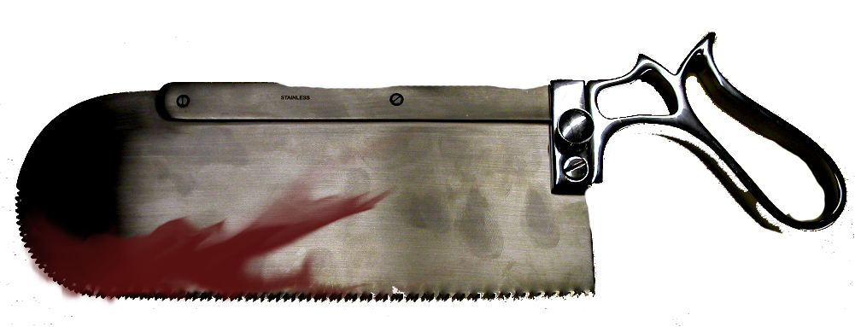
The bone-saw is a very close-range, low damage weapon, with a high rate-of-fire. It is picked up very early in the game and can be used as a last-resort weapon, or to break through certain objects (which can be wielded later).

Nail Gun
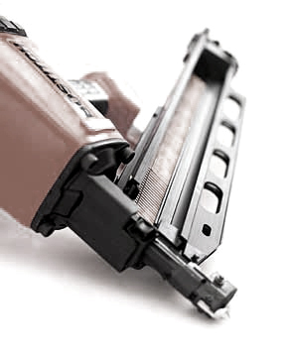
The nail gun is another weapon that can be picked up fairly early in the game also. It can be used as moderate defence against enemies, with the added ability to “pin” the limbs of monsters to the environment.

4.60
Camera Angles:

The player has the ability to switch between 1st and 3rd person view for a reason. During some levels, the ability to see more of your environment from your player’s perspective on the ground will be required to complete the level, as it will provide view to certain platforms or objects that may be required to head towards or manipulate.



[// 5.00]

5.10
Waking up // Cut scene

Yumi.

She wakes up in a daze… the room spins, blurred beyond comprehension.
An operating table…
Three eyes of light flood her retinas, as if filling her eyeballs in bright-white paint.

Another vein burns.

The room darkens.

Waking up again, she’s not where she was earlier, but it still feels stupidly familiar. She’s lying in an open coffin, filled with blood. She manages to remove a fleshy tentacle attached to her arm, taking in her surroundings.

The room is on fire, the walls, the ceiling and the floor, coated in a sea of flames. An ironically signed “Fire Exit” door illuminates brightly from the other side. Looking around, she notices a table fairly close to her.
A capsule sits neatly on its face in a cool, green glow.

This all can’t be real; it makes no sense… the thought of it drums around in her mind over and over… until the table shakes. She concentrates on the table, until it moves towards her, allowing her to take the antidote.

It felt cold.
Against the flames that surrounded her, it still felt ice cold.
Without thinking, she swallowed the capsule… a moment passes…

The flames wither and soak into the floor, disappearing as mysteriously as they had appeared…

As she walks through the door, she finds herself in a corridor. Another exit placed neatly at the other end.

Simple enough.

It’s only then that someone or something appears in front of her… another sharp pain… another torrent of battery acid floods her veins.

The corridor cringes and changes.
Yumi watches as the walls seem to melt, spikes drive themselves randomly into the ground, ceiling and opposing walls, before sinking back into the walls they originated from…

Perhaps not so simple…

----------------------------------------------
5.20
Yumi - Nightmares of Reality

Little is known of the main character and remains that way for a significant amount of the early game. As it happens, Yumi ‘Sixteen’ just happens to be the victim of a chemically induced psychedelic drug – currently in testing at a chemicals weapon facility.

As she wakes, she remembers very little. Her name is Yumi, she remembers that much – but only because the medical wrist-band she woke up with states it as fact… along with the number sixteen.

The drug produces temporary hallucinations and a schizophrenic psychotic state to the victim. Yumi is rendered lost in her own twisted imagination, so real that the mind has trouble coping with what is really reality and what are really the drugs hallucinations of reality.

The game starts post a serious incident at the facility, venting several bio hazardous toxins into the atmosphere, affecting all members of personnel – originally, leaving them in a mindless psychotic rage, all of which just happen to want to kill Yumi. Yumi must attempt to navigate her way through the medical facility, completing several increasingly dangerous tasks in order for her mind to overcome her surroundings.

Later on, she finds out she is actually a grown test-subject. An individual among a series of clones, all used purely for chemical testing of various drugs. She decides to take revenge for this perverse use of her body and strike the heart of her oppressors once and for all.

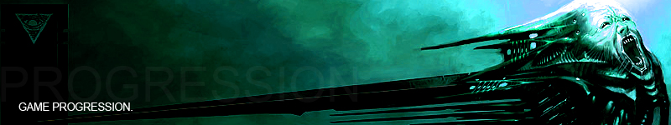

[// 6.00]

6.10
Levels:

Mindbreaker is split into several sections, with each section consisting of a variety of rooms or levels so to speak. Each room consists of a start point and an exit point, the simple primary objective being to reach the exit point. Secondary objectives include collecting all the antidote capsules, destroying monsters and doctors, along with completing other tasks which will lead Yumi to the real truth.

6.11
Early Complex:

The early complex consists of the medical bay, car park and short-bridge.

The Medical Bay is where Yumi begins, waking up. It is a fairly simple complex, but mostly is driven by several “room” and corridor based levels. Assets within these levels include that normally found in a hospital.

The Car Park is also fairly simple, but is a much larger environment, with different types of assets. It concludes the end of the early complex, as Yumi manages to escape the small medical bay and head via vehicle to the main hub of the facility.

6.12
Omerta Black:

Omerta Black is the name of the Chemical Weapons Manufacturers and also the primary medical facility. This complex consists of moderate difficulty, including several more large room and hangar based levels.

Research Ladders are the first quarters of the facility. Yumi will be faced with more puzzles and levels that consist of more than one room and/or corridor. There is a reduced number of monsters, however the navigation and platform aspect increases heavily, with environmental hazards.

The Neuro-Toxin levels are four stages, each consisting of increasingly difficult large maze like rooms. The monster count increases from the research ladders, with the original requirement for platform manipulation.

6.13
Clone Bay:

As Yumi reaches the end of her journey, she goes to destroy all of her clones and Omerta Black’s research mainframe.

The Clone Bay Complex consists of two underground bunkers. The first being the mainframe and the second being the actual Clone Bay. The difficulty of both these levels is extremely high, with an insane number of monsters and very difficult open-underground areas.

As Yumi destroys the mainframe, the bunkers begin to collapse, leaving the last level (the destruction of the clone-bay) extremely difficult, as pieces of the environment are constantly changing (with or without the antidote).

6.20

Simple Room Concept

6.21
Map Concept:
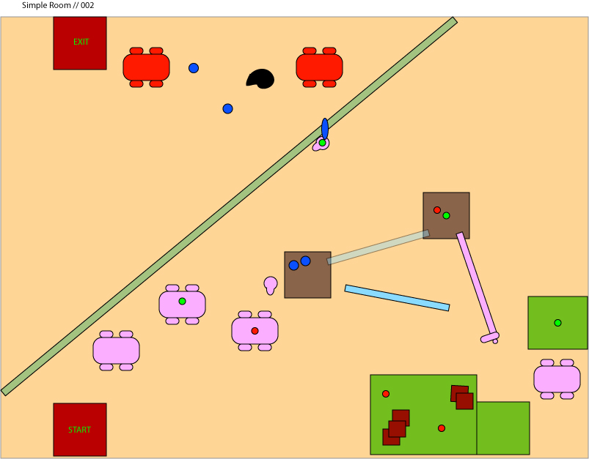

6.22
Map Key:
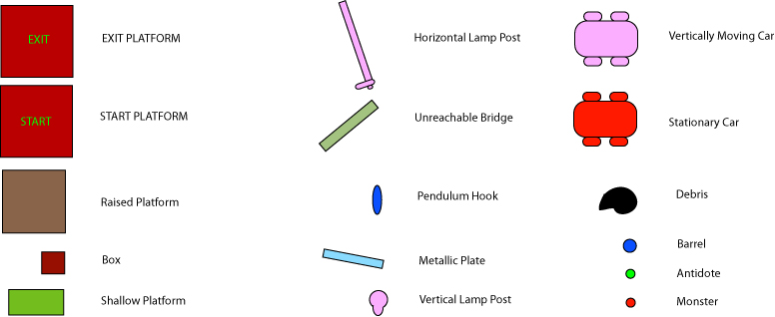

6.23
Level Walkthrough

- Player start point on raised platform, above floor of hazardous lava. First objective: Collect antidote on second floating car using run and jump moves.
- Antidote collection leads to the third floating car to be lowered to reachable heights; however it also spawns a monster on the roof of the car.
- Disposing of the monster, allows you to get access to the raised platforms, with barrels, which are also in range of some monsters across on the shallow platform.
- Using the metallic plate floating in the lava, a bridge must be made in order to access the raised platform ahead, which must be done while under attack by the monsters (unless dealt with previously via throwing boxes/barrels etc)
- Once access to this platform has been acquired, a doctor will spawn moments before collecting the antidote and attack, until the antidote is collected or the doctor dealt with. There is also a small twisted metallic box on this platform that is fairly incomprehensible.
- The lamp-post offers access to another shallow platform that may or may not have monsters on it at this point. If there are monsters, a fight using boxes must be carried out in order to stop them from allowing the player to use the floating car as a lift to the next raised platform.
- Collecting the antidote here, after killing the monsters causes the previously incomprehensible twisted metallic box to form into an interactive button.
- Pushing the button puts the pendulum in motion and extremely fast speeds. The metallic plate must be once again used to cross onto the lamp post and collecting the antidote that will spawn after collecting the previous. This antidote will slow the pendulum down enough to use it as a means to access the stationary cars below.
- Using the Wii controller, the player must then hop quickly across the cars and debris as they will sink into the lava if the player remains on them for too long.
- The exit and end of the level.

6.24
60 Seconds of Gameplay // Simple Room 002

This mission begins with Yumi exiting the Medical Bay and finding herself standing on a floating platform in the upper level car-park. The exit happens to be directly in front of her, but it isn’t as easy as it first sounds.

The sky and atmosphere is boiling, blistered reds and oranges, reflecting the heat of the surroundings. The floor is liquid lava, with several twisted, metallic structures, that can only really be described and cursed cars, floating unpredictably. Twisted metallic trees also scale high. Taking in ambience using inspiration from the Silent Hill musical composer of Akira Yamaoka, the ambience is extremely life like, yet very machine. A hybrid of flames, metallic screams and echo’s of F.E.A.R. like cries flood and reverberate around the level.

Yumi manages to jump across from her platform onto a floating car, just as it comes close enough for her to reach. It soon carries her into the air, towards another. Only just managing to jump onto the second floating car, she realises the third one she needs to reach is too high to reach the raised platform ahead of it. An antidote lies quietly on the car she is currently on, morphing the level into something new. The car that originally was too high, lowers itself slightly, only to reveal a monster standing ready to push her into the lava…

With quick thinking, Yumi notices some barrels on the platform ahead. She grabs one with her mind, pulling it close to her chest… waiting another second as the monster lines up with her aim. She takes one or two fireballs, which are easily deflected by the shielding barrel, before catapulting the barrel into him. The monster falls untidily into its fiery grave below, but she doesn’t give it a second glance, as she leaps onto the car and following platform. It doesn’t look good however…

The platform rests high above the lava, with another platform sitting ahead, with an odd, incomprehensible metallic structure gracing its surface. There is no bridge linking the two… yet. Two monsters stand on a far platform, throwing knives and boxes over towards Yumi’s platform, as they are unable to cross the lava. Yumi grabs a box in mid-flight and throws it back, watching as it collides into one of them, sending him into the floor. The last monster stands, continuing to throw knives as he now has run out of boxes.

A metallic plate of some sort seems to be floating in the lava below. Yumi grabs it again, pulling it towards her, before placing it back down – bridging the gap between the two platforms. She runs over it, tossing the second barrel at the monster across of her that she had been using as a shield from the throwing knives beforehand. It misses pathetically, bouncing twice and falling into the lava.

Just as she gets to the second platform, a monster appears out of nowhere, making an attempt at her life. He wields a chainsaw and manages to tear through a small portion of Yumi’s left arm. Her mind goes clouded for a moment, but she notices the antidote. She stumbles over to it just before the monster manages a second hit, causing him to disappear in a puddle of ash. However, the initial hit brought her health rapidly low, she moves a lot slower and sluggish. Not the best of times, considering she now has to manoeuvre herself over across a, once metallic tree, which now was a sideways lamp-post. As she reaches the second platform, she jumps onto a floating car, using it as a lift onto another platform above. Picking up the antidote, she notices the metallic structure on the platform she has walked across earlier has now turned itself into a button.

Yumi makes her way back to the platform, hitting the button. A large maintenance hook begins to pendulum its way across a large segment of the car-park and terrifying speeds. She plans it carefully… she needs to use the metallic plate from earlier as a bridge. Just as the hook screams passed, she places the plate across from her platform… onto the head of a lamp-post. She runs across, making it to the lamp-post, just as the pendulum returns, knocking the metallic plate back into the lava. As she grabs the last antidote of the level, the pendulum slows down, giving her the ability to use it as a new means to reach the cars ahead.

Taking a final leap off of the aerial hook, Yumi hop-scotches her way over cars and floating barrels that consistently decide to sink if she stands on them for too long, but as her feet land on the exit platform, everything feels better.



[//7.00]

There are not many similar games that can really relate to Mindbreaker, especially as a platform genre. However, one title that comes very close is:

American McGee's Alice

AMA is a third-person, platform shooter, developed by Rogue Entertainment and published by EA, released Oct 6th 2000.

Powered by the Quake III engine, the game developed a large fan-base and was given lots of praise, scoring an average percentage for its time, of 82% overall.

With the upcoming release of Alice, the movie in 2007, Mindbreaker should be a fresh come back, with enhanced graphics, sound, game play and interactivity on levels only for the modern-day consumer market.

