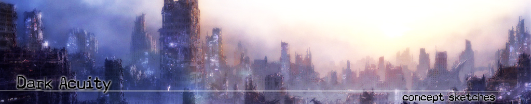
Concept: Dark Acuity

Background:

Time warps.
Parallel Dimensions.
A simple change in fate.

Dark Acuity is a concept spawning from the simple question of “What if…?”

With several deep philosophical perspectives and beliefs on fate, free-will and “Gods command”, Dark Acuity dives into the realms of how our modern day life could be, if certain changes were made to our history.

Setting:

Dark Acuity is set in outskirts of City PF/346. The world is divided by race and region, as government paranoia consumes an active Defcon stalemate, everyone waiting for the other to make the first move. A concept quite possible for several styles of genre, including first and third person RPG’s or FPS’s, with the possibility of MMORPG’s. Examples such as Neocron and the upcoming Huxley could have been candidates to adopt similar backgrounds.

Level:

The level is based primarily within a mid-level apartment, in an apartment building. The apartment itself is filled with everything you would probably find in a modern-day studio. Bedroom, kitchen and lounge area are all included, primary assets including a wide-screen TV, computer complete with an LCD monitor, tables and kitchen ornaments – with a much darker ambience outside of the building itself.

Set at night, the silhouetted images of sentry guns and APC’s, illuminated by street lights, emphasise the martial law run environment the level lives within.

Assets:

Bedroom:
Computer Tower
Computer LCD Screen
Wardrobe
Lamp
Bed
Bedside Table

Kitchen:
Sink
Fridge
Bar-table

Lounge:
Couch
Low-glass table
Tall lamp
Widescreen TV

Miscellaneous:
Lamp post
Sentry
Prototype 12
APC
Bench

Scheduling:

 | Dark Acuity Schedule
October
 | Week 1 |  | Concept Sketches
 | Week 2 |  | Concept Sketches
 | Week 3 |  | Concept and Development of Prototype 12 (High Quality Asset)
 | Week 4 |  | Apartment Square Concept Sketches + Illustrator Layouts
November
 | Week 1 |  | Bedroom Asset Development
 | Week 2 |  | Bedroom Asset Development + Lounge Asset Development
 | Week 3 |  | Lounge Asset Development + Kitchen Asset Development
 | Week 4 |  | Kitchen Asset Development + Bathroom Asset Development
December
 | Week 1 |  | Completion of Room Assets / Level Development
 | Week 2 |  | Completion of Room Assets / Level Development for Final Deliverable

Inspiration:

Apartments – Kitchen Environments:

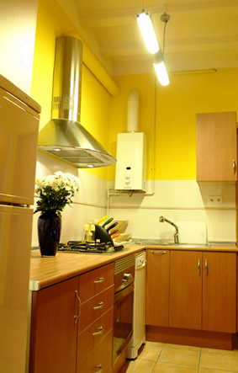
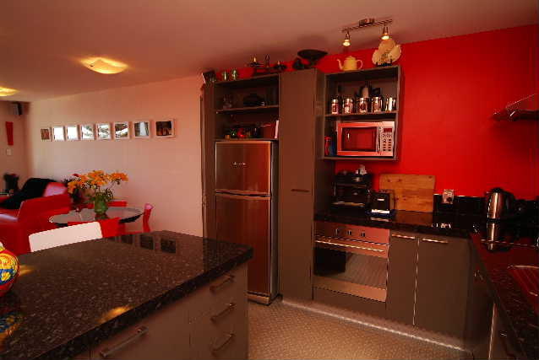

- Inspiration taken from several sources. The above two pictures offered a good modern-day kitchen appearance. With wood and chrome/granite desktops.
- Since a lot of the apartment will probably be of Japanese orientation, red and white might be an idea for colours, with hints of black borderlines.
- Granite tops would require specular mapping + glossiness

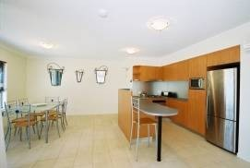

- The image directly left is a very good representation of the lounge – kitchen orientation. Except the lounge in this case being the dining area.

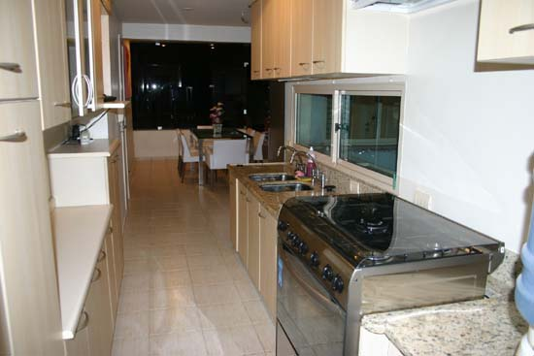

- Possible cooker model

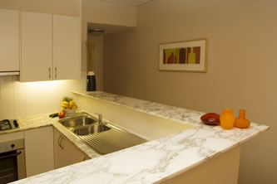
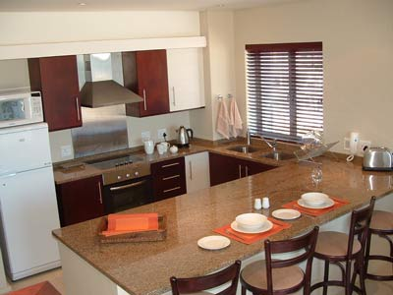

- The first picture, with the marble coloured kitchen desktop consisted with inspiration subject to the chrome sinks. One of the high-level assets that will be included for this room.
- The second picture (right) adds an idea of possible mahogany blinds along with a slightly wider kitchen arrangement to include an integrated dining area. The cooker itself, with the overhead ventilation should prove to be very useful for the inspiration for the cooker model.
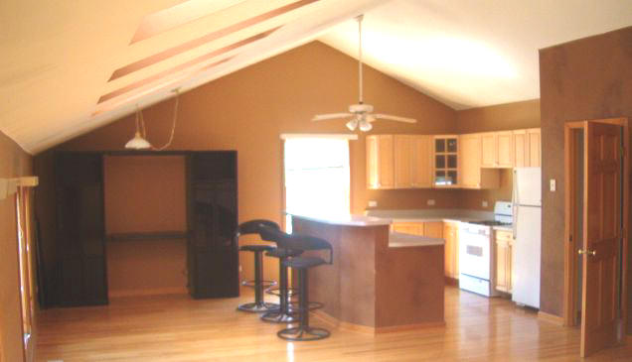

- Overhead fan as apartment decoration?
- Angular ceiling.
- Strange stools – could prove to be model assets.

Apartment – Bedroom Environments:
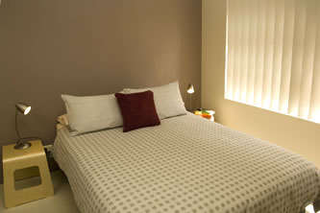

- The first picture is a good idea of how I want the bed itself to look, however with an IKEA style backboard and possibly lower to the ground, to bring a more Japanese-esque style to the environement.

- The side lamp tables are also quite interesting.

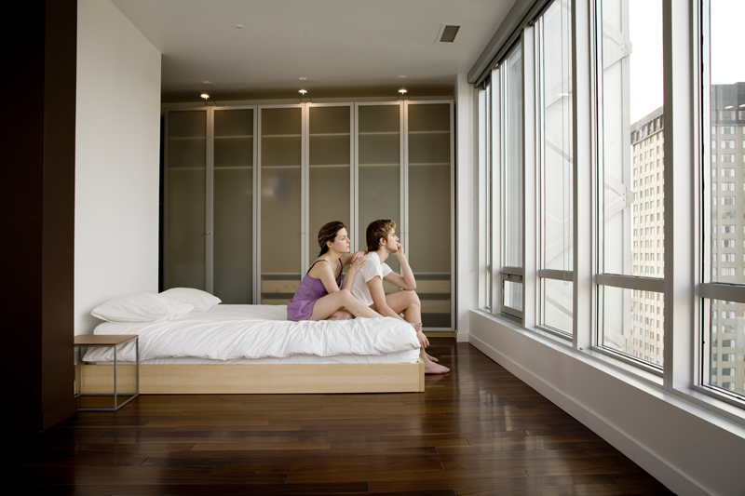
- This second picture is the kind of height that I want for the bed itself, as an asset in the bedroom.

- The lights on the wardrobe are also something that I would to include for that asset also.

- A very basic side-table offers interesting ideas.

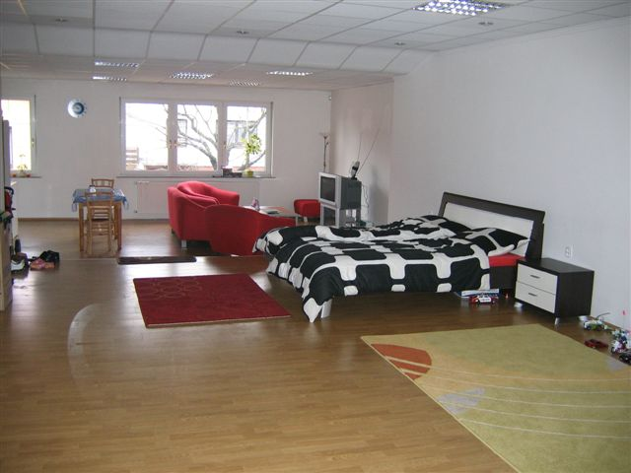
- What caught my attention with this particular picture, although the floors itself are perhaps not the style I’m looking for, is the overall size and studio-style appearance of the apartment.

- The white walls are also something I’m considering as far as lighting is concerned for the final level.

Apartment – Lounge Area:

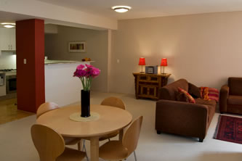
- I liked the general setting of this lounge, especially the colours and accent pillar in the centre. It is something I am definitely considering for my finished illustrator level.

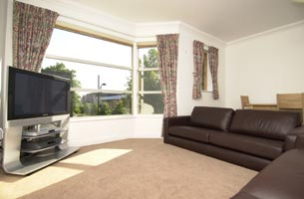
- The small seating table, that seems to be more there for décor than anything, could also be included to make it feel more authentic.

- I did not like the outline of this general picture, however, the orientation of the sofas and widescreen TV caught my attention.

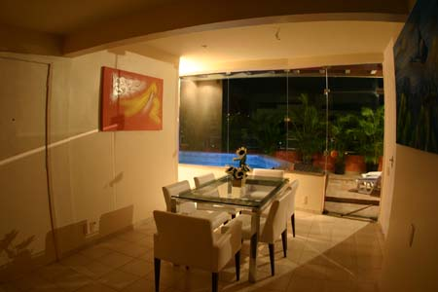
- Glass screens and the glass table. This particular picture has a lot of transparency and could offer a much more unique setting
- // Even though it looks nice, I don’t know if I want to consider this style, considering it would be silly to have so much glass during a war…

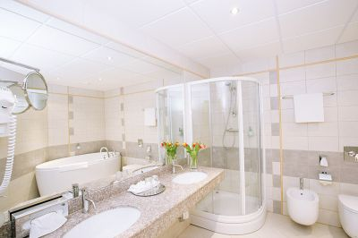
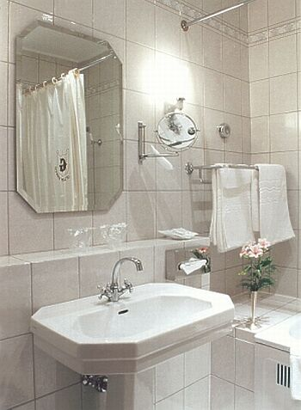
- The size of this particular bathroom caught my attention. It is about the right size I’m looking for. The long sided mirror is also something I’m considering

- The hexagonal style of bathroom here caught my attention; it seems to have a sort of “futuristic” appeal to it, along with possibly keeping an oriental aura.

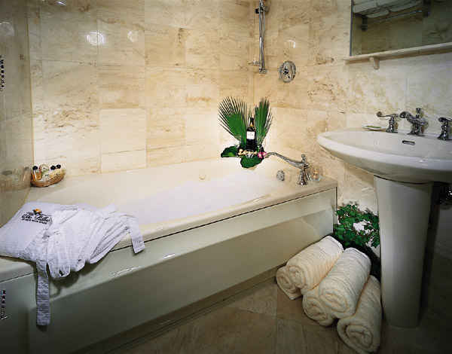
- The below picture is actually taken from a hotel bathroom, which are considerably different to that found in your average apartment. However, this is the kind of feeling I want to give the apartment level none-the-less (closely looking you can see Japanese writing on the bath and screen).

Apartment Complex – Outside Concepts:

- After considering several ideas for what kind of city landscape I wanted, I found several post-apocalyptic concept sketches that really brought across the idea I was after. Below are a few of those concept sketches, for what kind of ambience I want to bring to my level.
- Another thing to take into account is I’ve been considering a merge of post-modern environments with past assets, except that in line with military technology. For if war was this close, more money would probably have gone into the research and production of much more higher-tech gear than in our current period.
- This idea would probably be taken into account for buildings as well, but not necessarily what is inside of them.
